TFB Review: Smith & Wesson M&P15-22 Pistol
Posted May 21, 2021 in AR Patterned, Reviews, Rifles, Rimfire, Semi-Auto by Sam.S with 37 Comments
Tags: M&P, M&P15-22, pistol brace, pistol., Smith & Wesson
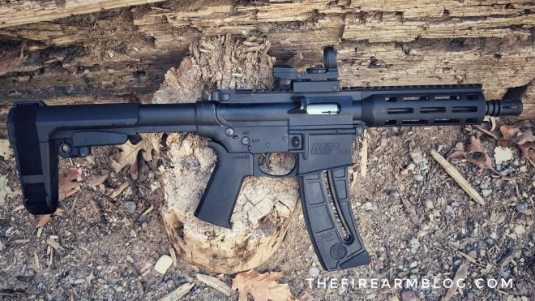
Back in December, I had the chance to let you guys know about Smith & Wesson’s newest addition to their M&P15-22 line of firearms being the M&P15-22 Pistol. This pistol technically existed previously before being discontinued. The difference is that the older version had no pistol brace and the new one has an SB Tactical SBA3 Adjustable Arm Brace. Recently I purchased my own M&P15-22 Pistol and I am excited to give you all my review of it. Let’s dive into the rabbit hole!

Specifications: Smith & Wesson M&P15-22 Pistol
The Smith & Wesson M&P15-22 Pistol comes in a cardboard S & W box lined with foam. It comes with one 25 round magazine, manual, warranty information, chamber flag, and cable lock. Unfortunately, I misplaced the box so I do not have an out-of-the-box photo like I usually do, so I apologize.
- SKU: 3321
- Model: M&P®15-22 PISTOL
- Caliber: 22 LR
- Capacity: 25 Rounds
- Magazine: One 25 Round Magazine
- Optics Ready: Yes
- Safety: Manual
- Overall Length: 22.8˝ (57.9 cm) Collapsed, 25.4˝ (64.5 cm) Extended
- Width: 2.0˝ (5.08 cm)
- Overall Height: 7.0˝ (17.78 cm
- Pistol Grip: Magpul® MOE SL®
- Action: Semi-Auto Blow Back
- Barrel Material: Carbon Steel
- Barrel Finish: Black
- Receiver Material: Polymer
- Receiver Finish: Black
- Barrel Twist: 1:15
- Barrel Length: 8″ (20.32 cm)
- Weight: 53.6 oz.
Note: The Truglo DUAL COLOR OPEN DOT SIGHT does not come with the Smith & Wesson M&P15-22 Pistol. I added this after I purchased the pistol.
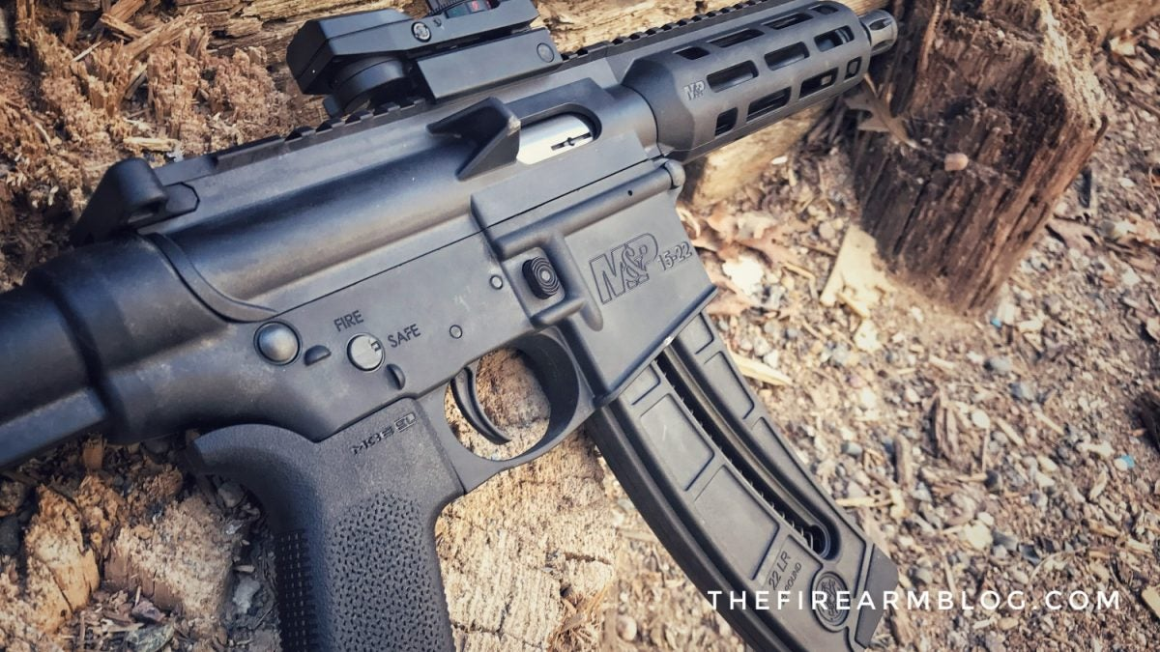
The MSRP of the Smith & Wesson M&P15-22 Pistol sits fairly at $504. I say fairly cause it is a gun that works well (go more in-depth in the range section) and to be honest, if you are not familiar with the M&P15-22 series they are almost entirely polymer besides the very important parts. You saw the specifications above but Smith & Wesson goes into more detail below:
OTHER FEATURES: M&P® Handguard with
M-LOK® Slots, 2 Position, Receiver-Mounted Safety Lever, Functioning Charging Handle and Shell Deflector, SB Tactical SBA3 Adjustable Arm Brace With Closure Strap, Magpul® MOE SL® Grip, Full Length Picatinny-Style Rail, One-point QD Sling Swivel Attachment Point in Arm Brace, Threaded Barrel with Flash Suppressor.

Range Time: Smith & Wesson M&P15-22 Pistol
Range time with the Smith & Wesson M&P15-22 Pistol was just fine. I say it like that cause when it comes to any firearm made for 22 rimfire, they tend to be relatively inconsistent. I have put around 350 rounds through the Smith & Wesson M&P15-22 Pistol and have had zero failures and malfunctions. This gun runs flawlessly and I really enjoy plinking with it. I did the same sort of torture test I do with any 22 I review and own. I use multiple grain weights and even old gross-looking ammo mixed in just to see if anything will jam up on me.
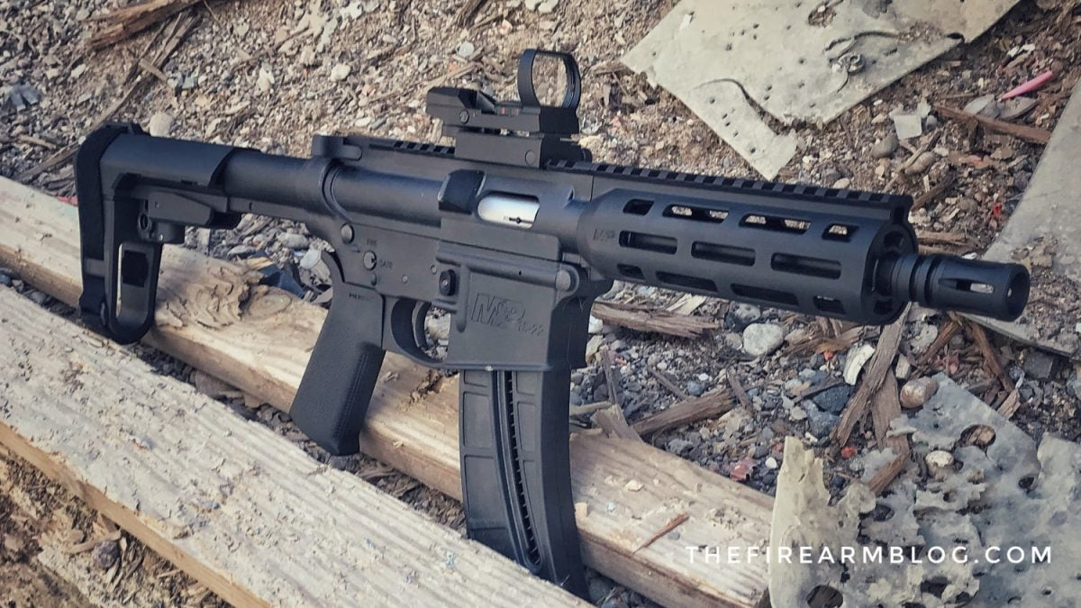
One very fun aspect of the Smith & Wesson M&P15-22 Pistol is the birdcage on the muzzle can be easily unthreaded and I attached my Dead Air Mask HD 22 suppressor. This thing with a suppressor is fantastic albeit a tad bit louder than you would prefer due to the barrel length not allowing the high-velocity rounds to stay at a lower velocity. I did use up two magazines of subsonic ammunition to see the difference and although it was much quieter I have to admit I am a little frugal with the subsonic in the current state of the world. Well worth it if you decide that’s how you want to shoot it though! Still zero malfunctions.

Final Thoughts: Smith & Wesson M&P15-22 Pistol
If you were thinking of getting an AR-style 22 and you wanted something small and compact to train, practice, LARP, or just have fun, I would recommend this pistol. The only potential downfall I see with it is it has a higher probability of breakage if you are rough with it. I by no means am saying it felt fragile to me because it definitely did not. Heck, I wouldn’t have bought it if I thought I could break it. I can just see this thing developing a crack or a break if it was forced to bend or put under some sort of extreme pressure.
The MSRP is super fair like I stated above and it sits right there in the same range as its rifle counterpart if that is more your style. Any extra money you save could be put towards ammunition, optics, sling, or even a suppressor. This is one purchase I do not regret and I hope others have had as positive an experience with theirs that I have had with mine! I am very glad they brought it back the way they did.
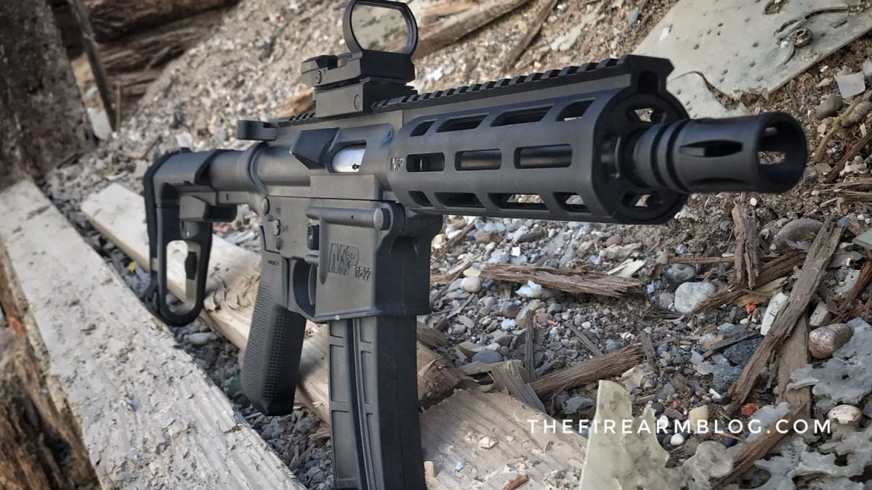
In closing, I want to say thank you to Smith & Wesson for allowing TFB and myself the opportunity to try out their M&P15-22 Pistol! That is greatly appreciated. Also, we would like to know what all of you guys and gals think? Do you believe that this variant of the M&P15-22 series is something worth spending your money on? Would you run to the range with this lightweight plinker? Would this be your go-to fun gun at the range? Let us know all of your thoughts in the Comments below! We always appreciate your feedback.
